**Value every life !**

**Love mankind!**

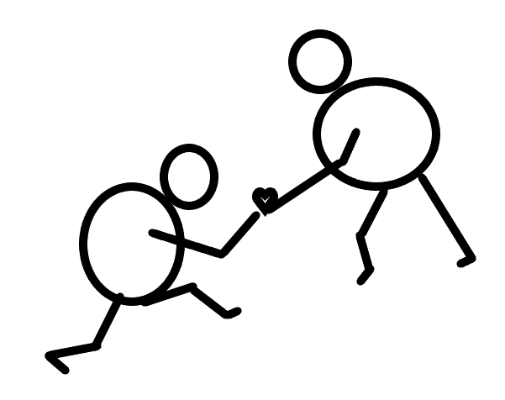

Written By Sarthak Nadkarni

Date: January 6th, 2021